Lab 9: Unstructured Data and Cortex LLM functions

1. Activate Notebook

1. Produce a listing of the supplied PDF files

1. Text Extraction example

1. Insert into new table

1. Classify text

1. Classification example

1. Run an analytical query

1. Visualize data with Streamlit

1. Translate function

1. Summarize example

1. Check your work – Check 10

1. Create a table with variant data type

1. Load JSON data

1. Query semi structured data

1. Create view

1. Check 11

1. Knowledge Check

1. End session

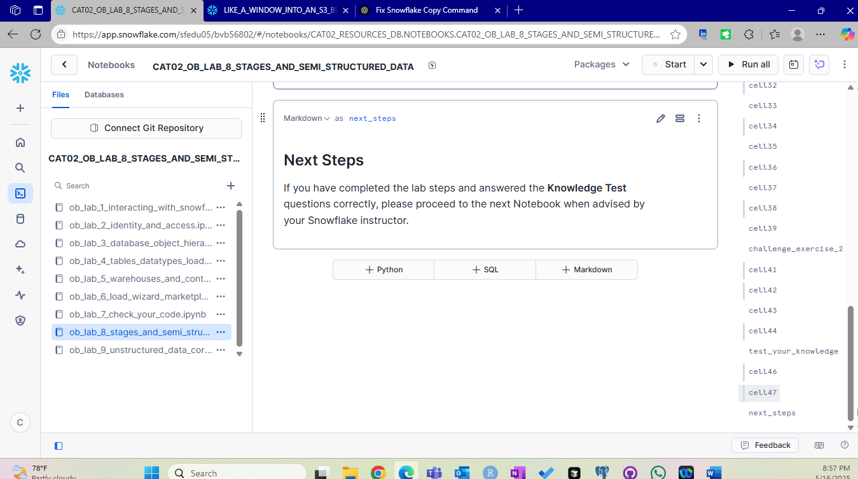

Summary :

We begin this lab by dealing with unstructured data (PDF Files, images, audio, video) . We first list the pdf files in the staging area. After viewing a sample file, we use the Cortex LLM function parse the document. This parsing helps us to bring the data into a semi structured format. We then insert this information into a table. Then we create a new column in the table which classifies the data into fruit , veggie or flower. This is very easy as the LLM is helping us here. To visualize the data, we use Streamlit. Additionally we use Translate, Summarize, complete function. We end the lab by closing the session after answering the questions in the knowledge check.